IAM TASK

- Create one IAM user and assign EC2 and S3 full access roles
To avoid using the Root Account: Because root user have unlimited access. If root credentials get leaked then your entire AWS account was in risk. So we create normal IAM users for day-to-day tasks. For individual identity
- To allow the permissions IAM is allow you to give required permissions
- For security
  - Step by step
go to the AWS consol
Go to the IAM
Select the user
Create the user
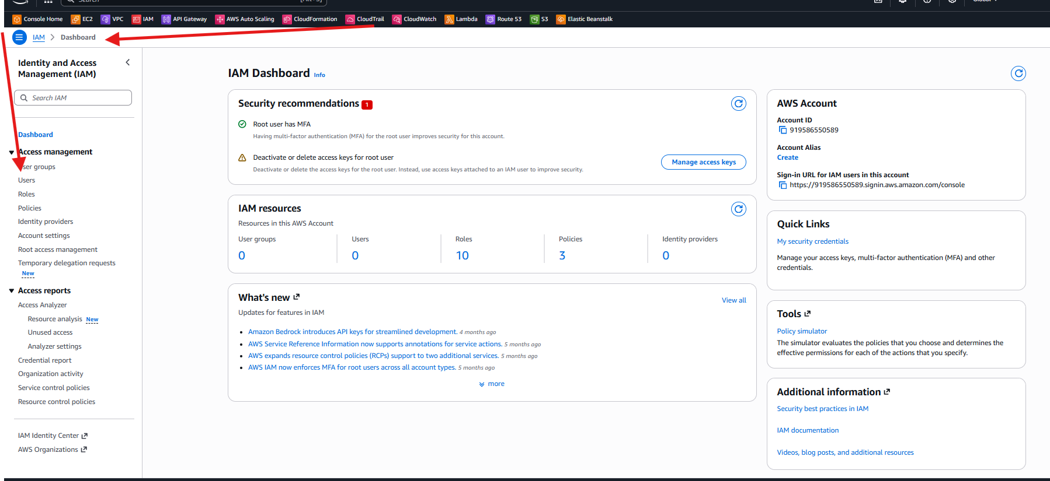
Give the name to user
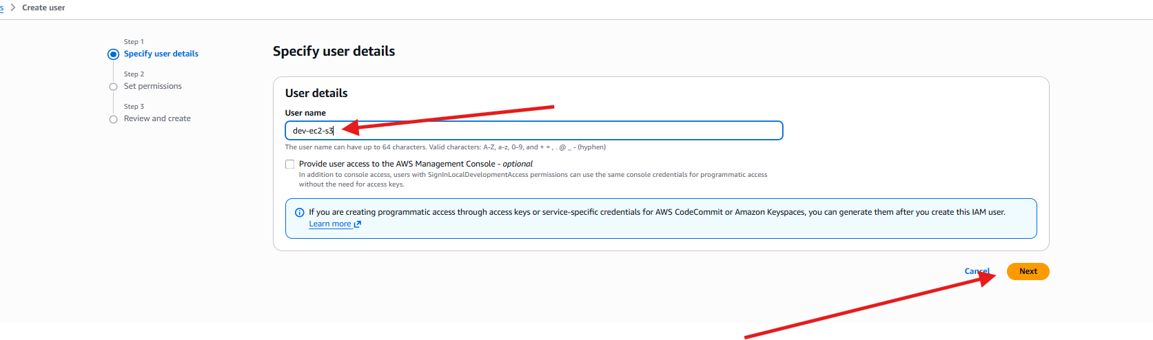
Give the permissions to EC2 full access
And also give s3 full access

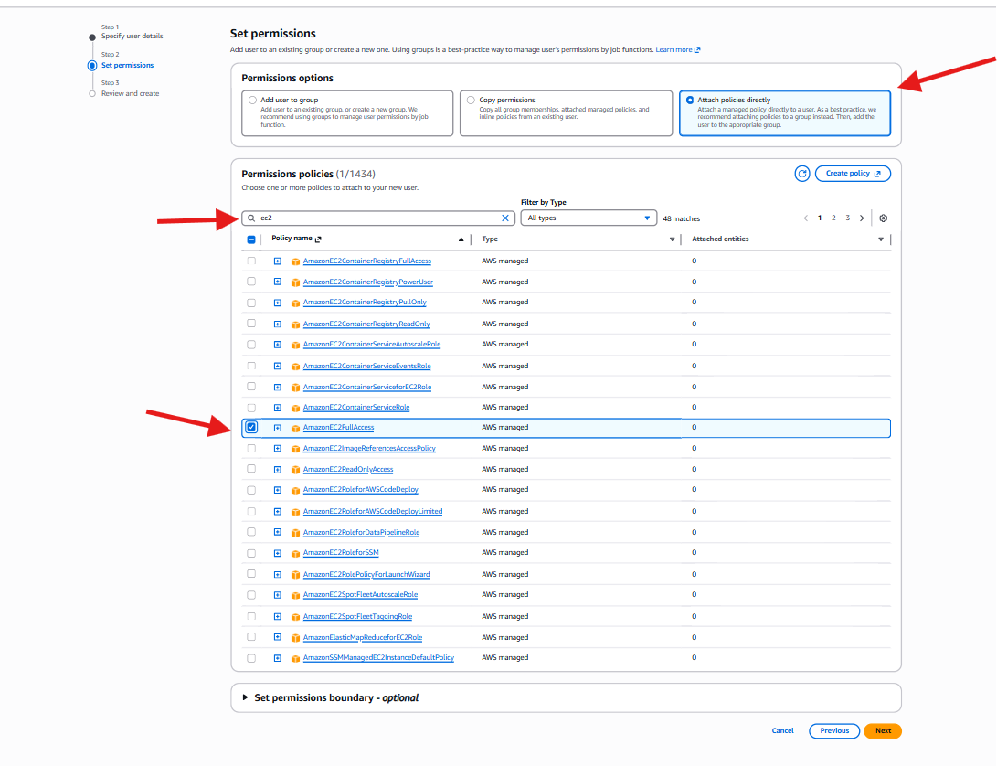

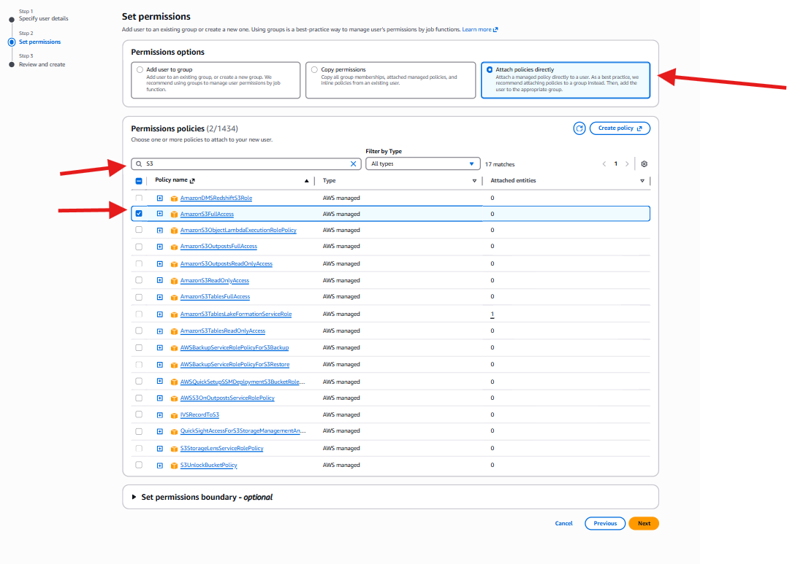
We can see clear hear in the image I have given full access to the ec2 and s3
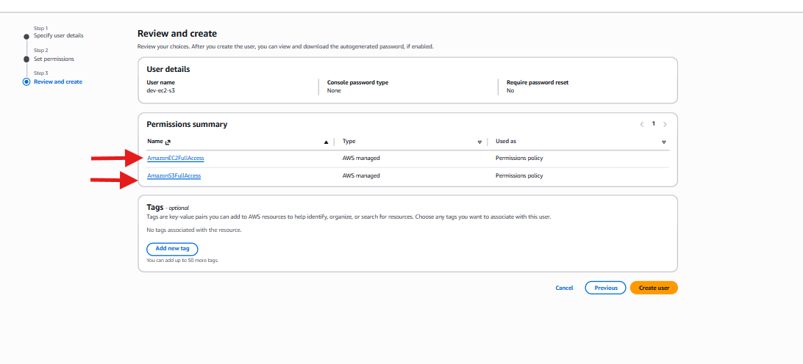
User is created and also
- Create one group in IAM and assign read access for EC2.
We are creating user group to permissions and security and to give monetering only access . prevent additional changes like stop instance terminate instance and edit security group . supporting devops workflow
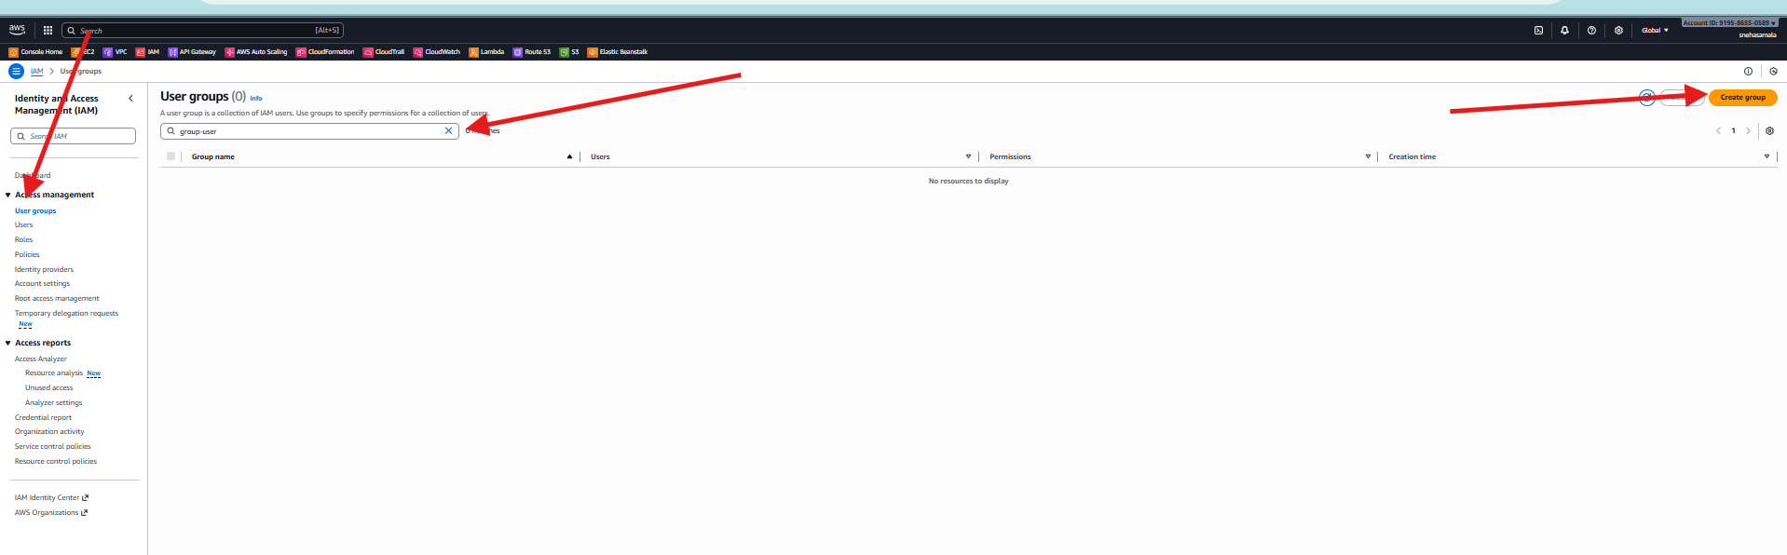
Created the users group and and given full access sto the ec2
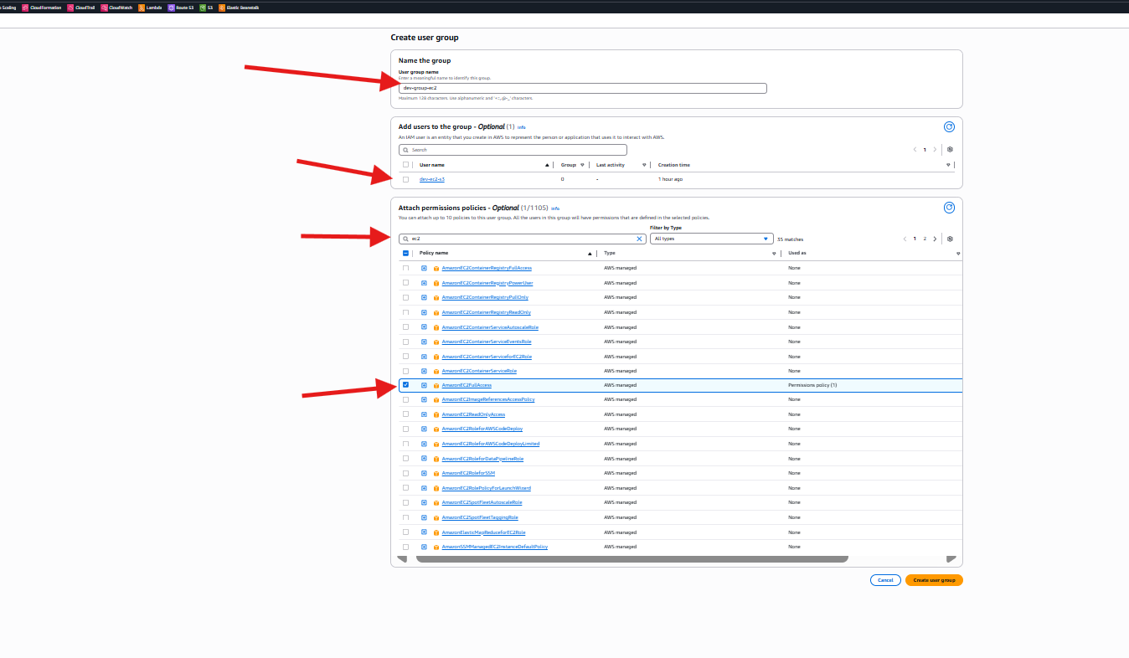
Given full access to Ec2
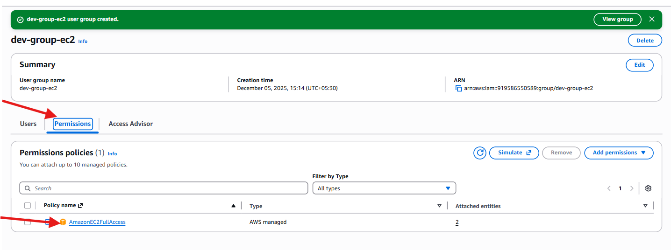

- Create a new user named "Devops" and add to the group created in task 2.
  - To centralization permissions: assigned permissions to the all the user one-by-one and give the permissions to the group .
  - Consistency access control : because all team members in the same group and same level . there is no chans to geta specific permission to the one user
  - Security Best Practice : assigning permissions to the group not for the uers
This reduce the mistakes

Created the group and done with permissions read only access

Done with permissions policies
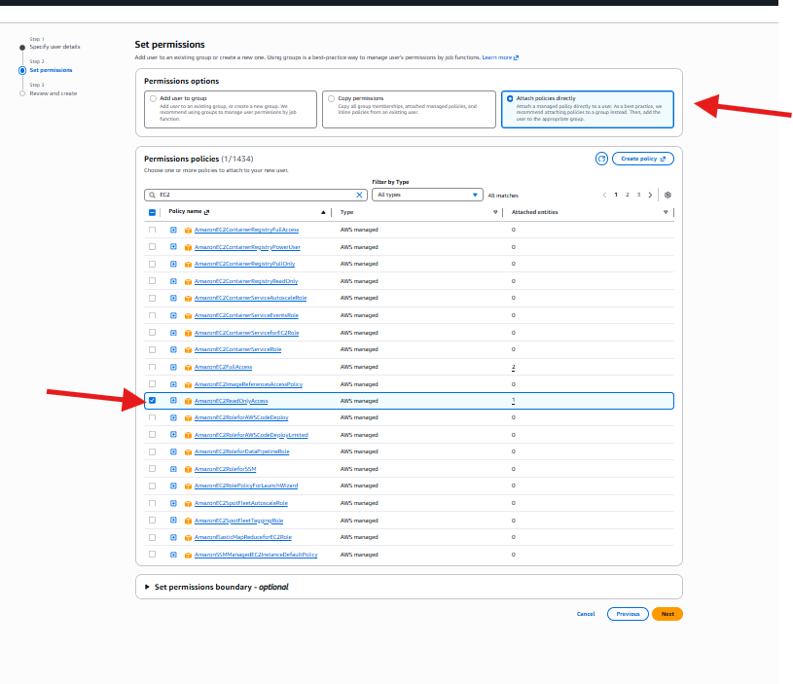
Created and permissions
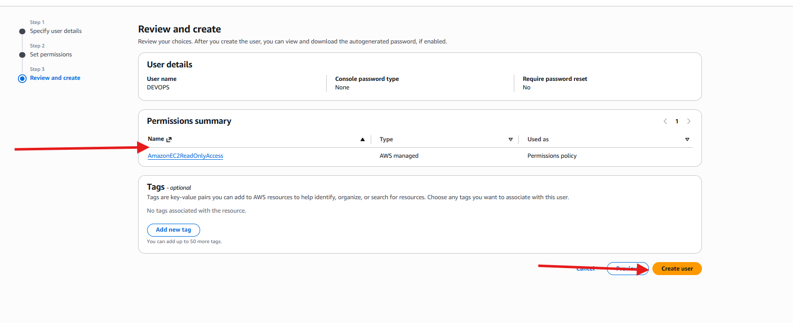
Created the user with permissions
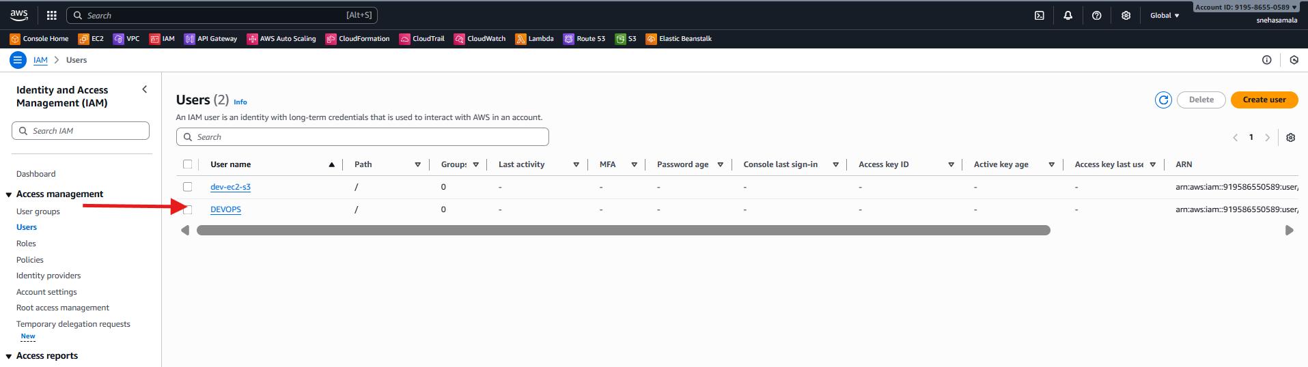
Done successfully
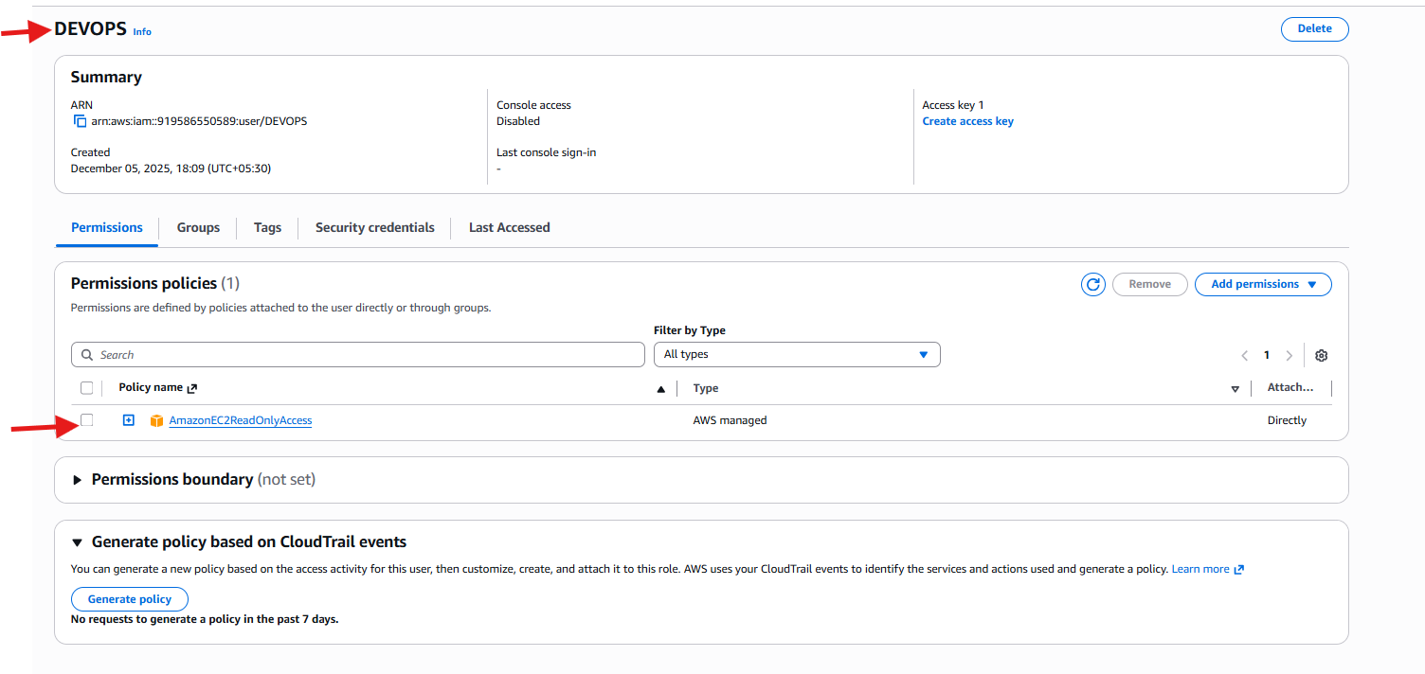
- Write a bash script to create an IAM user with VPC full access.
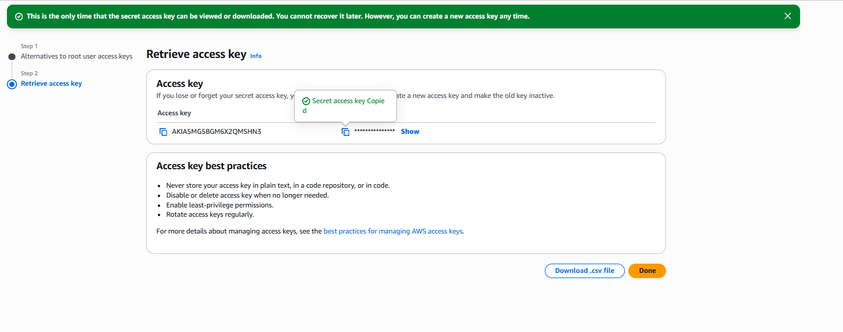
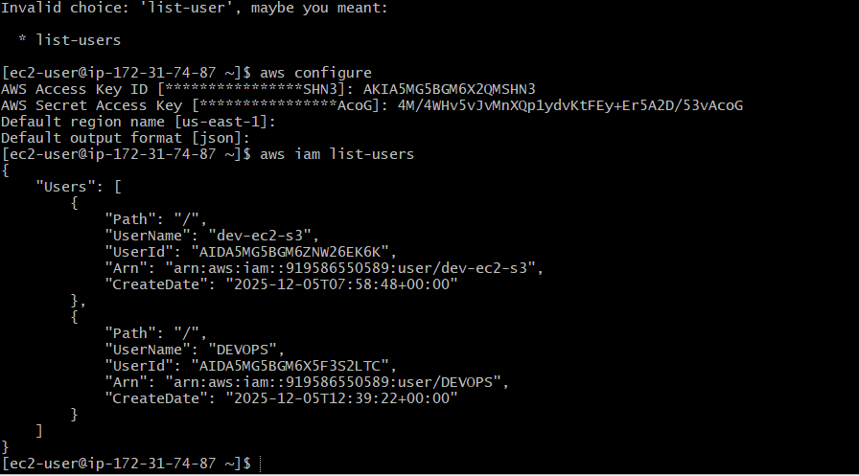
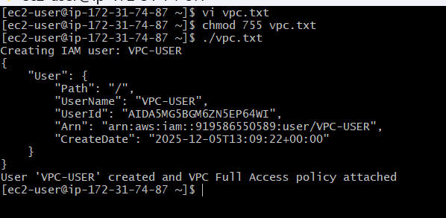
Successfully created the user
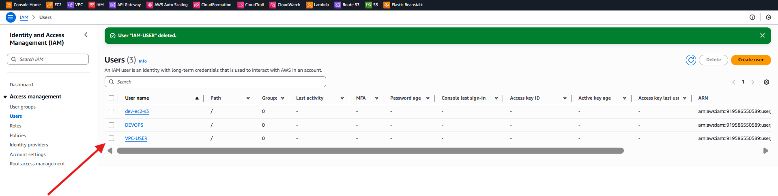

- Create an IAM policy to allow EC2 access for a specific user in specific regions only.
Create the policy
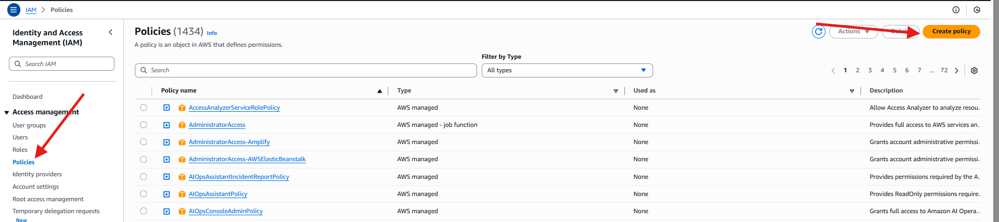
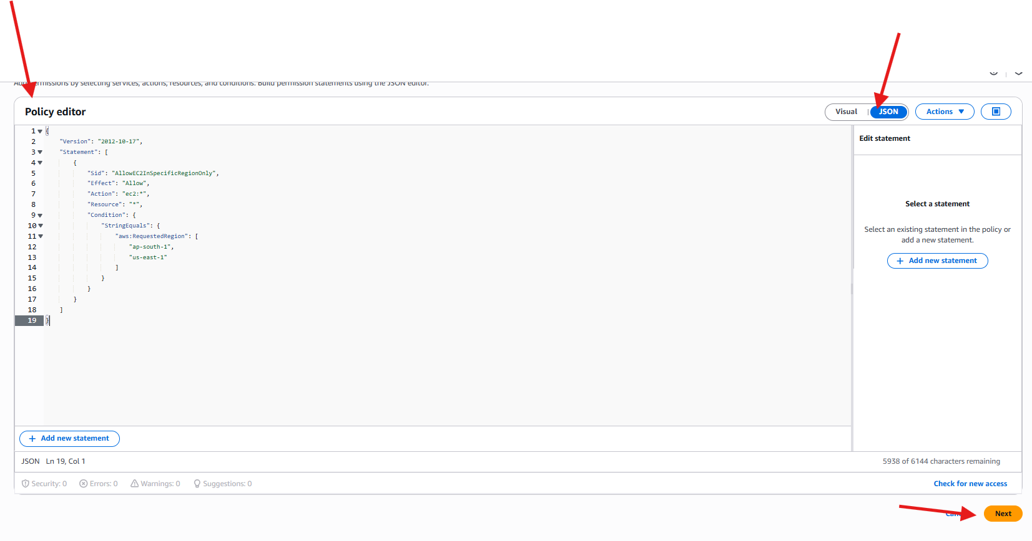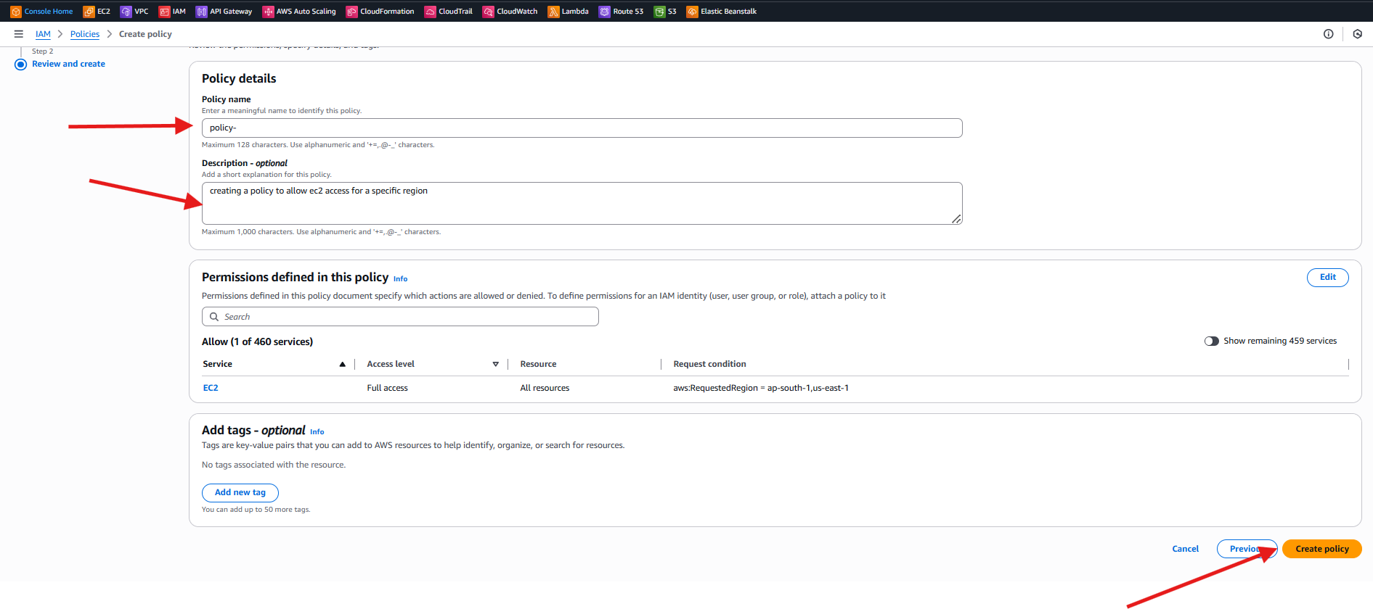
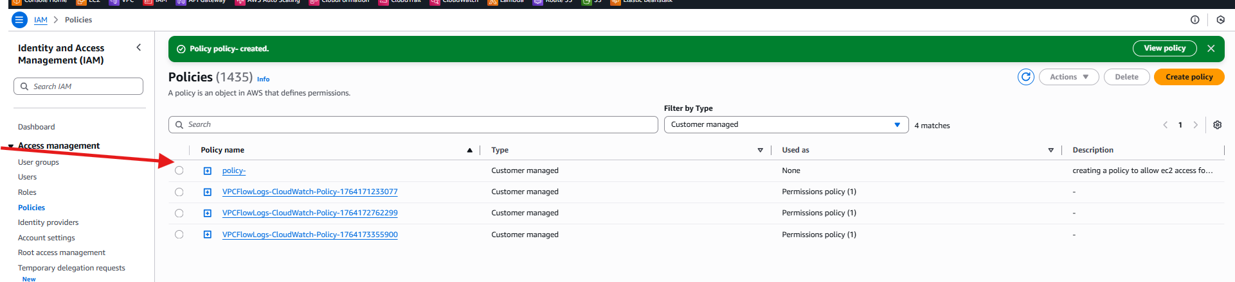
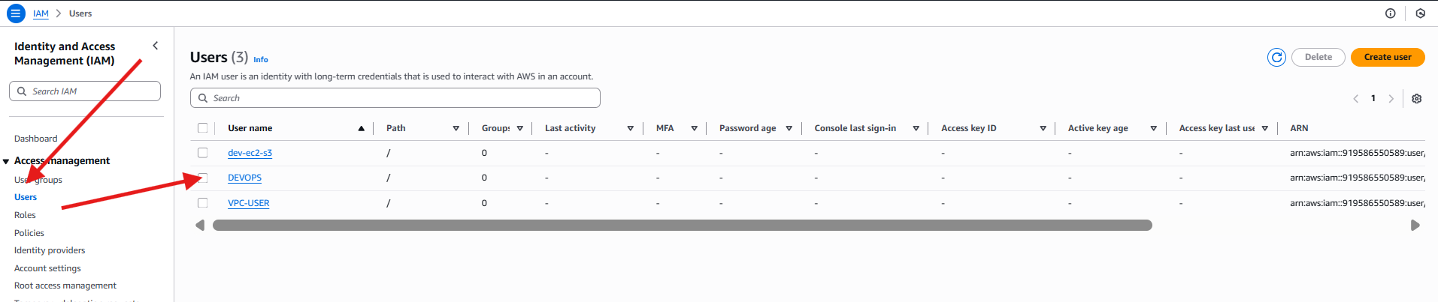

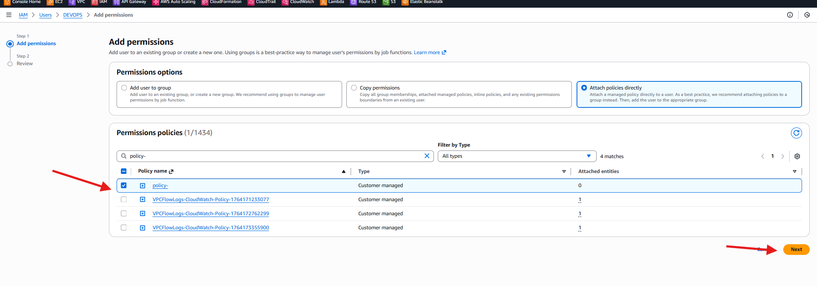
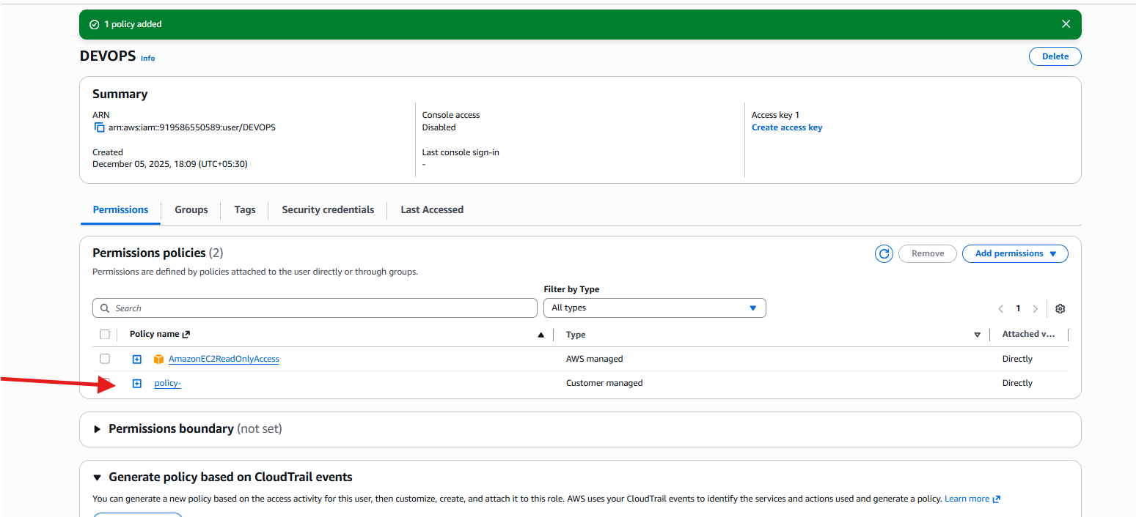
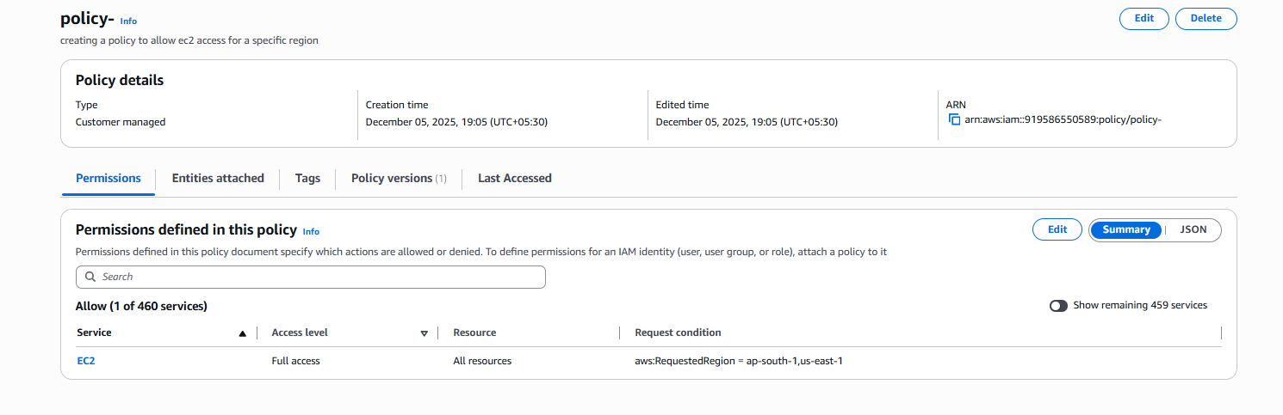

- We have two accounts: Account A and Account B. Account A user should access an S3 bucket in Account B.
Create one bucket and done with script and give permissions
And uploaded file
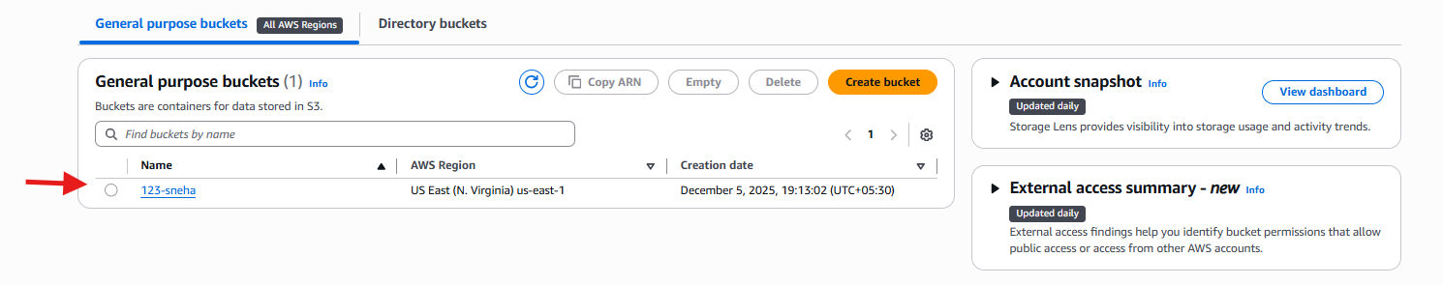
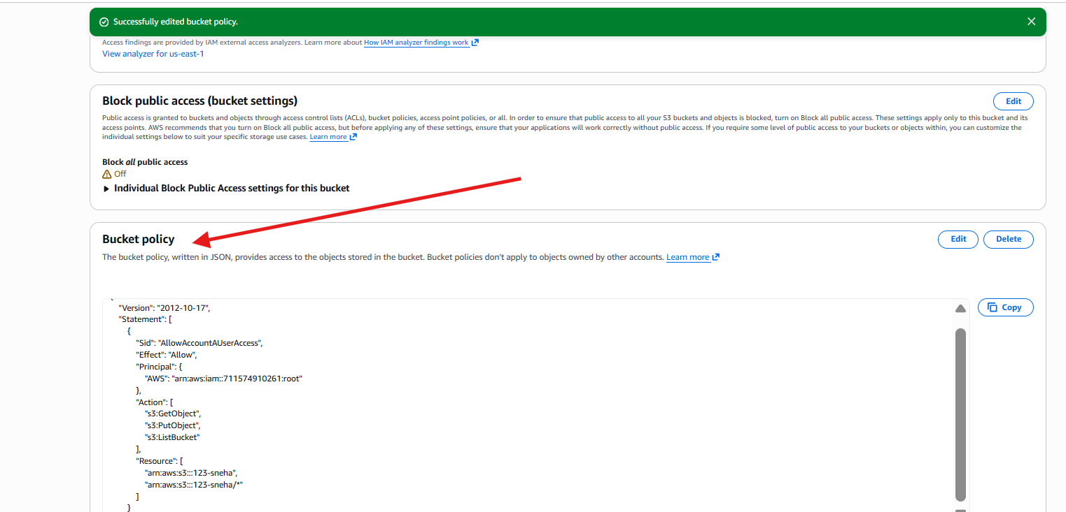
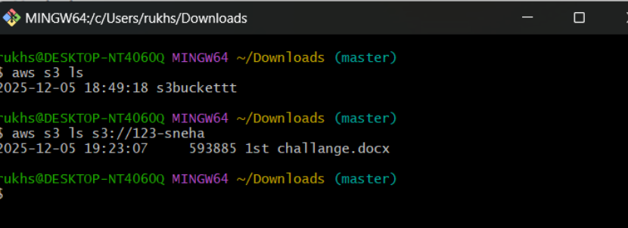

- (Collaborate with a team member and execute this. This is mostly asked in every interview.)

